**DREAM HOME DATABASE ASSIGNMENT 1**

**CS 5332**

**FALL 2016**

**Instructor: PROF.DR.C.J.HWANG**

**SUBMITTED TO: PROF.DR.C.J.HWANG SUBMITTED BY: ANUSHA VATTAM**

**TEXAS STATE ID: A04701078**

**TABLE1 BRANCH:**

CREATE TABLE Branch(BranchNo VARCHAR(10), Street VARCHAR(25), City VARCHAR(15),

Postcode INTEGER, CONSTRAINT pk_BranchNo PRIMARY KEY(BranchNo) );

**Table Branch is created**

**INSERT INTO STATEMENTS:**

INSERT INTO Branch(BranchNo, Street, City, Postcode) VALUES ('B005','800 N LBJ DRIVE','Texas',78666);

1 row inserted.

INSERT INTO Branch(BranchNo, Street, City, Postcode) VALUES ('B007','700 N LBJ DRIVE','Texas',78666);

1 row inserted.

INSERT INTO Branch(BranchNo, Street, City, Postcode) VALUES ('B003','600 Main street','Austraila',45556);

1 row inserted.

INSERT INTO Branch(BranchNo, Street, City, Postcode) VALUES ('B004','500 Aquarium street','London',78856);

1 row inserted.

INSERT INTO Branch(BranchNo, Street, City, Postcode) VALUES ('B002','300 Dallas street','Raliey',45456);

1 row inserted.

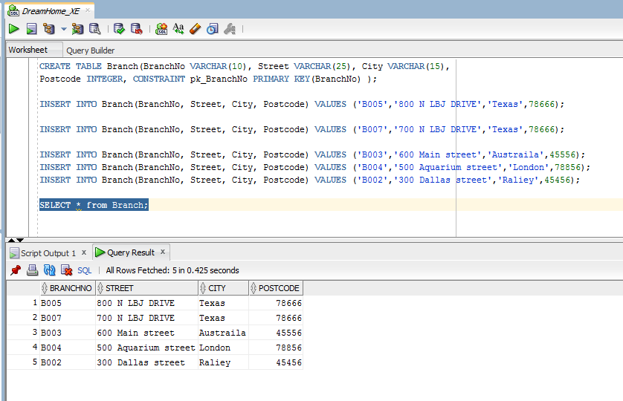

**TABLE 2 STAFF**

CREATE TABLE Staff ( StaffNo VARCHAR(10) , FName VARCHAR(10), LName VARCHAR(10) ,Position VARCHAR(20), Sex VARCHAR(10),DOB VARCHAR(20), Salary INTEGER ,BranchNo VARCHAR(10), CONSTRAINT pk_StaffNo PRIMARY KEY (StaffNo),CONSTRAINT fk_branchNo FOREIGN KEY (BranchNo) REFERENCES Branch(BranchNo));

**Table STAFF created.**

**INSERT INTO STATEMENTS**

INSERT INTO Staff(StaffNo, FName,LName,Position,Sex,DOB,Salary,BranchNo) VALUES ('SL21','John','White','Manager','M','1 oct 1945',30000,'B005');

1 row inserted.

INSERT INTO Staff(StaffNo, FName,LName,Position,Sex,DOB,Salary,BranchNo) VALUES ('SG37','Ann','Beach','Assistant','F','10 Nov 1960',120000,'B003');

1 row inserted.

INSERT INTO Staff(StaffNo, FName,LName,Position,Sex,DOB,Salary,BranchNo) VALUES ('SG14','David','Ford','Supervisor','M','14 Mar 1958',180000,'B003');

1 row inserted.

INSERT INTO Staff(StaffNo, FName,LName,Position,Sex,DOB,Salary,BranchNo) VALUES ('SA9','Mary','Howe','Assistant','F','3 Oct 1994',9000,'B007');

1 row inserted.

INSERT INTO Staff(StaffNo, FName,LName,Position,Sex,DOB,Salary,BranchNo) VALUES ('SG5','Susan','Brand','Manager','F','24 Jun 1990',24000,'B003');

1 row inserted.

INSERT INTO Staff(StaffNo, FName,LName,Position,Sex,DOB,Salary,BranchNo) VALUES ('SL41','Julie','Lee','Assistant','F','8 Dec 1988',9000,'B005');

1 row inserted.

SELECT * from Staff;

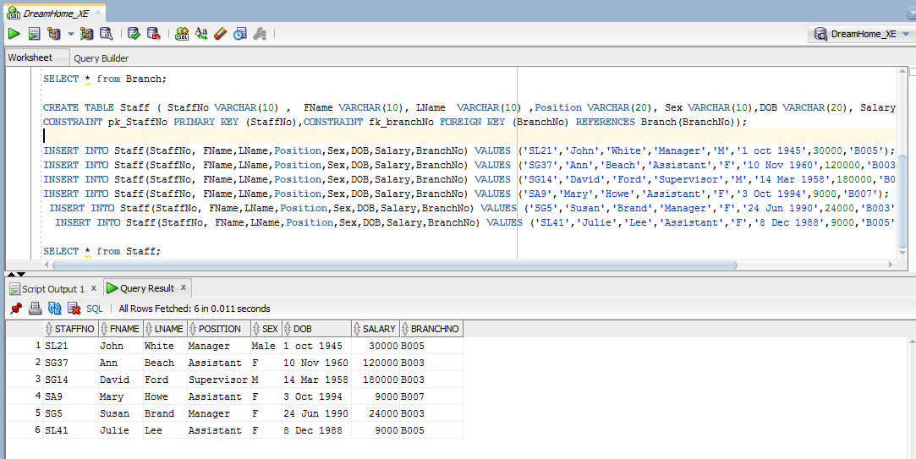

**TABLE 3 PropertyForRent**

CREATE TABLE PropertyforRent(PropertyNo VARCHAR(10),Street VARCHAR(20),City VARCHAR(10) ,Postcode INTEGER, Type VARCHAR(10),Rooms INTEGER, Rent INTEGER ,ownerNo VARCHAR(10),StaffNo VARCHAR(10),BranchNo VARCHAR(10), CONSTRAINT pk_PropertyNo PRIMARY KEY (PropertyNo), CONSTRAINT fk_prownerNo FOREIGN KEY (ownerNo) REFERENCES PrivateOwner(ownerNo), CONSTRAINT fk_prStaffNo FOREIGN KEY (StaffNo) REFERENCES Staff(StaffNo), CONSTRAINT fk_prBranchNo FOREIGN KEY (BranchNo) REFERENCES Branch(BranchNo));

**Table PROPERTYFORRENT created.**

**INSERT INTO STATEMENTS**

INSERT INTO PropertyForRent (PropertyNo,Street,City,Postcode,Type,Rooms, Rent,OwnerNo, StaffNo, BranchNo)

VALUES ('PR14','16 holhead','Aberden',78666,'House',4 ,2000,'OW46', 'SA9','B007');

1 row inserted.

INSERT INTO PropertyForRent(PropertyNo,Street,City,Postcode,Type,Rooms,Rent,OwnerNo,StaffNo,BranchNo) VALUES ('PR94','700 LBJ','London',75966,'Flat',2,1500,'OW87','SL41','B005');

1 row inserted.

INSERT INTO PropertyForRent(PropertyNo,Street,City,Postcode,Type,Rooms,Rent,OwnerNo,StaffNo,BranchNo)

VALUES ('PR4','500 Dale Rd','Glasgow',45656,'House',3,2000,'OW40','SG5','B003');

INSERT INTO PropertyForRent(PropertyNo,Street,City,Postcode,Type,Rooms,Rent,OwnerNo,StaffNo,BranchNo)

VALUES ('PR36','Novar','TN',78666,'House',4,2000,'OW93','SG37','B003');

1 row inserted.

INSERT INTO PropertyForRent(PropertyNo,Street,City,Postcode,Type,Rooms,Rent,OwnerNo,StaffNo,BranchNo)

VALUES ('PR21','10 Manor Rd','Galveston',67665,'Flat',3,450,'OW87','SG37','B003');

1 row inserted.

INSERT INTO PropertyForRent(PropertyNo,Street,City,Postcode,Type,Rooms,Rent,OwnerNo,StaffNo,BranchNo)

VALUES ('PR16','6 Argyll','Texas',78686,'Flat',4,550,'OW93','SG14','B003');

1 row inserted.

SELECT * from PropertyForRent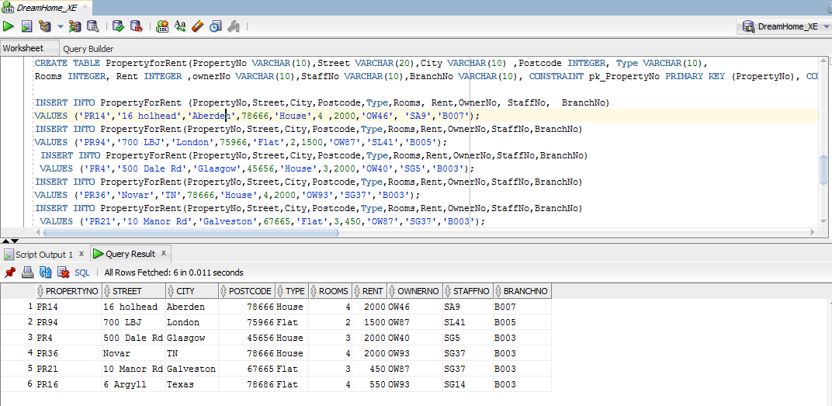

**TABLE 4 CLIENT**

CREATE TABLE Client( ClientNo VARCHAR(10) , FName VARCHAR(8), LName VARCHAR(8) ,TelNO VARCHAR(15), PrefType VARCHAR(8), MaxRent INTEGER ,

email VARCHAR(30), CONSTRAINT pk_clientNO PRIMARY KEY (ClientNo));

Table CLIENT created.

**INSERT INTO STATEMENTS**

INSERT INTO Client(ClientNo, FName,LName,TelNo,PrefType,MaxRent,email) VALUES ('CN76','John','Kay','762-665-2072','Flat',425,'jok12@gmail.com');

1 row created.

INSERT INTO Client(ClientNo, FName,LName,TelNo,PrefType,MaxRent,email) VALUES ('CN56','Alice','Stwerat','772-600-1772','Flat',355,'as12@gmail.com');

1 row created.

INSERT INTO Client(ClientNo, FName,LName,TelNo,PrefType,MaxRent,email) VALUES ('CN74','Riche','Rich','0142-600-2967','House',789,'rr12@gmail.com');

1 row created;

INSERT INTO Client(ClientNo, FName,LName,TelNo,PrefType,MaxRent,email) VALUES ('CN62','Mary','Ritche','512-665-6789','Flat',2000,'mary56@gmail.com');

1 row created.

SELECT * from Client;

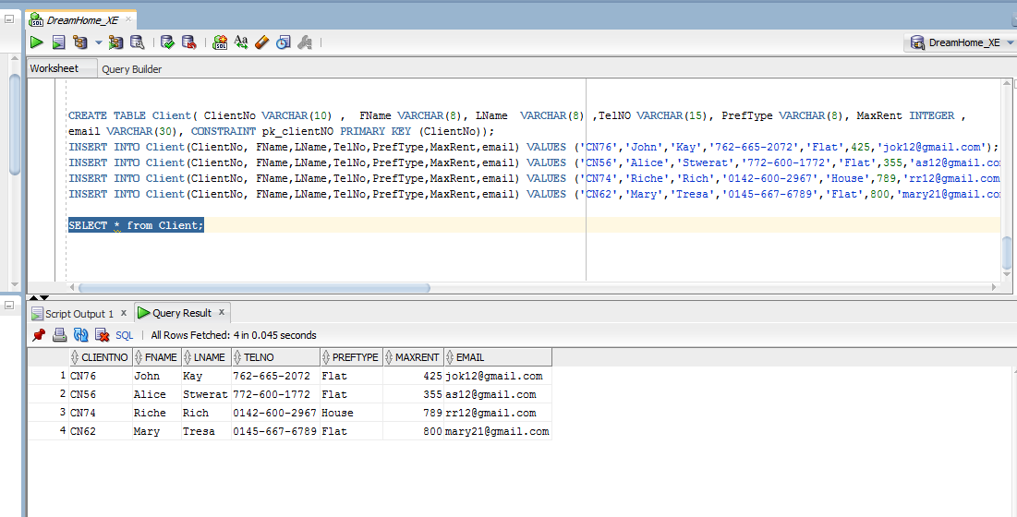

**TABLE 5 PRIVATEOWNER:**

CREATE TABLE PrivateOwner( ownerNo VARCHAR(10) , FName VARCHAR(8), LName VARCHAR(8) ,Address VARCHAR(20),TelNO VARCHAR(15),email VARCHAR(30), Password VARCHAR(15), CONSTRAINT pk_OwnerNo PRIMARY KEY (ownerNo));

**Table PRIVATEOWNER created**.

**INSERT INTO STATEMENTS**

INSERT INTO PrivateOwner(ownerNo,FName,LName,Address,TelNo,email,Password) VALUES ('OW46','JOE','Keogh','2 Fergue Dr TX','512-665-3456',

'jk56@gmail.com', '******');

1 row inserted.

INSERT INTO PrivateOwner(OwnerNo, FName,LName,Address,TelNo,email,Password) VALUES ('OW40','Tony','Gaddis','6 Achary st,TN','512-635-5611',

'tg45@gmail.com', '*****');

1 row inserted.

INSERT INTO PrivateOwner(OwnerNo, FName,LName,Address,TelNo,email,Password) VALUES ('OW87','Tina','Murphy','63 Wells st,G42','752-943-5611',

'tmu45@gmail.com', '******');

1 row inserted.

INSERT INTO PrivateOwner(OwnerNo, FName,LName,Address,TelNo,email,Password) VALUES ('OW93','Carol','Shaw','12 Park ,TX','755-943-5611',

'cs45@gmail.com', '****');

1 row inserted.

SELECT * from PrivateOwner;

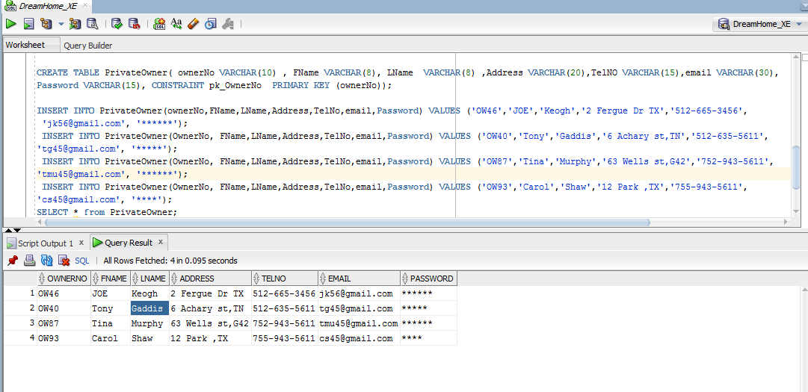

**TABLE 6 VIEWING**

CREATE TABLE Viewing( ClientNo VARCHAR(10) , PropertyNo VARCHAR(10),ViewDate VARCHAR(15) ,Comments VARCHAR(20), CONSTRAINT pk_clientnopropertyno PRIMARY KEY (ClientNo,PropertyNo),CONSTRAINT fk_vClientNo FOREIGN KEY (ClientNo) REFERENCES Client(ClientNo),CONSTRAINT fk_vPropertyNo FOREIGN KEY (PropertyNo) REFERENCES PropertyForRent(PropertyNo));

**Table VIEWING created.**

**INSERT INTO STATEMENTS**

INSERT INTO Viewing(ClientNo,PropertyNo,ViewDate,Comments) VALUES ('CN56','PR14','12 Aug 2012','Too small');

1 row inserted.

INSERT INTO Viewing(ClientNo,PropertyNo,ViewDate,Comments) VALUES ('CN76','PR4','20 April 2013','Too remote');

1 row inserted.

INSERT INTO Viewing(ClientNo,PropertyNo,ViewDate,Comments) VALUES ('CN56','PR4','26 May 2014','');

1 row inserted.

INSERT INTO Viewing(ClientNo,PropertyNo,ViewDate,Comments) VALUES ('CN62','PR14','11 June 2015','no dinning room');

1 row inserted.

INSERT INTO Viewing(ClientNo,PropertyNo,ViewDate,Comments) VALUES ('CN56','PR36','28 Jan 2016','');

1 row inserted.

SELECT * from Viewing;

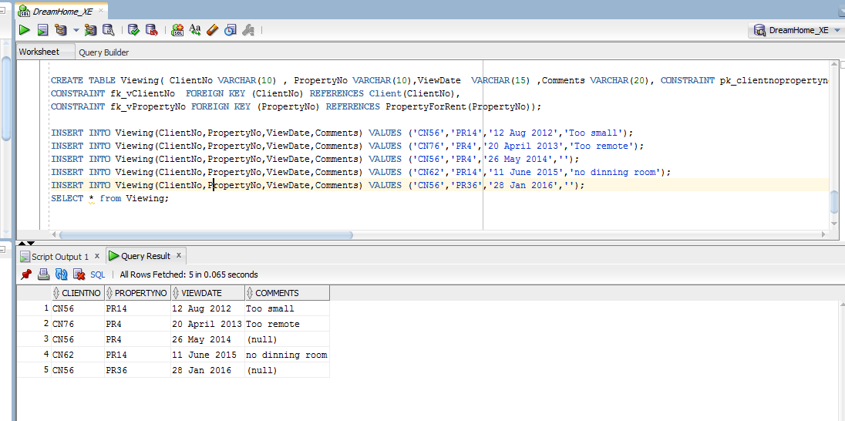

**TABLE 7 REGISTRATION:**

CREATE TABLE Registration( ClientNo VARCHAR(10) ,BranchNo VARCHAR(10), StaffNo VARCHAR(15) ,DateofJoin VARCHAR(20), CONSTRAINT pk_rclientnoBranchNO PRIMARY KEY (ClientNo,BranchNo), CONSTRAINT fk_rClientNo FOREIGN KEY (ClientNo) REFERENCES Client(ClientNo), CONSTRAINT fk_rBranchNo FOREIGN KEY (BranchNo) REFERENCES Branch(BranchNo));

**Table REGISTRATION created.**

**INSERT INTO STATEMENTS**

INSERT INTO Registration(ClientNo,BranchNo,StaffNo,DateofJoin) VALUES ('CN76','B005','SL41','21 June 2013');

1 row created.

INSERT INTO Registration(ClientNo,BranchNo,StaffNo,DateofJoin) VALUES ('CN56','B003','SG37','11 April 2012');

1 row created.

INSERT INTO Registration(ClientNo,BranchNo,StaffNo,DateofJoin) VALUES ('CN74','B003','SG7','16 Nov 2011');

1 row created.

INSERT INTO Registration(ClientNo,BranchNo,StaffNo,DateofJoin) VALUES ('CN62','B007','SA9','7 March 2012');

1 row created.

